POST LAB 4 TASK

NAME ; YUSRA ANSARI
ROLL NUMBER: 26K-3132
SECTION : BSE-1D

NOTE:
- This file was also uploaded on github according to the teacher’s instructions.
- The code of some tasks is distributed on more than 1 page , so please check the other page also for complete code

TASK 1
Code
#include <stdio.h>

int main()
{
float obtained_marks;
float family_income;
printf("Enter your obtained marks in %% : ");
scanf("%f", &obtained_marks);
printf("Enter your family income in Rs. : ");
scanf("%f", &family_income);
if((obtained_marks>=80) || (family_income<50000)){
printf("You are eligible for the scholarship.");
}
else{
printf("You are not eligible for the scholarship.");
}
return 0;
}

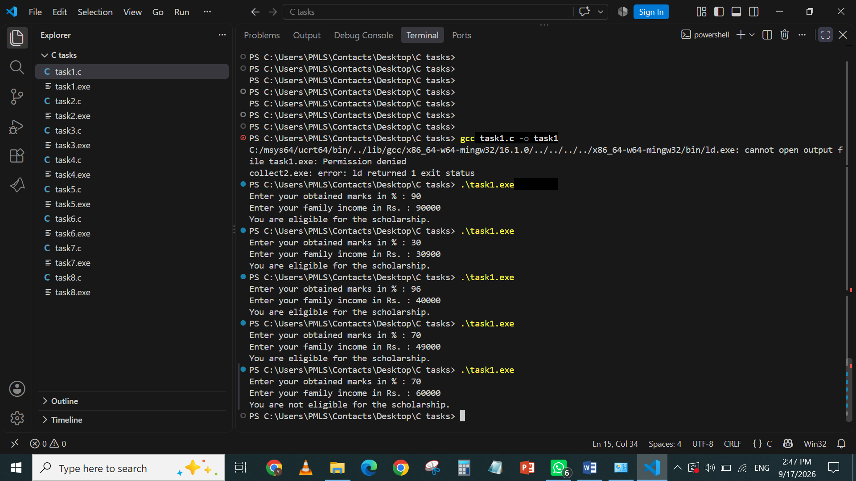
OUTPUT

TASK 2
CODE
#include <stdio.h>

int main()
{
int latedays;
printf("Enter the number of late days :");
scanf("%d", &latedays);
if(latedays == 0){
printf("No Fine");
}
else { if(latedays>0)
{
if (latedays<=5)
{
printf("Fine: Rs.50");
}
else { if(latedays<=10){
printf("Fine: Rs.100");
}
else{
printf("Fine: Rs.200");
}
}
}
}
return 0;
}

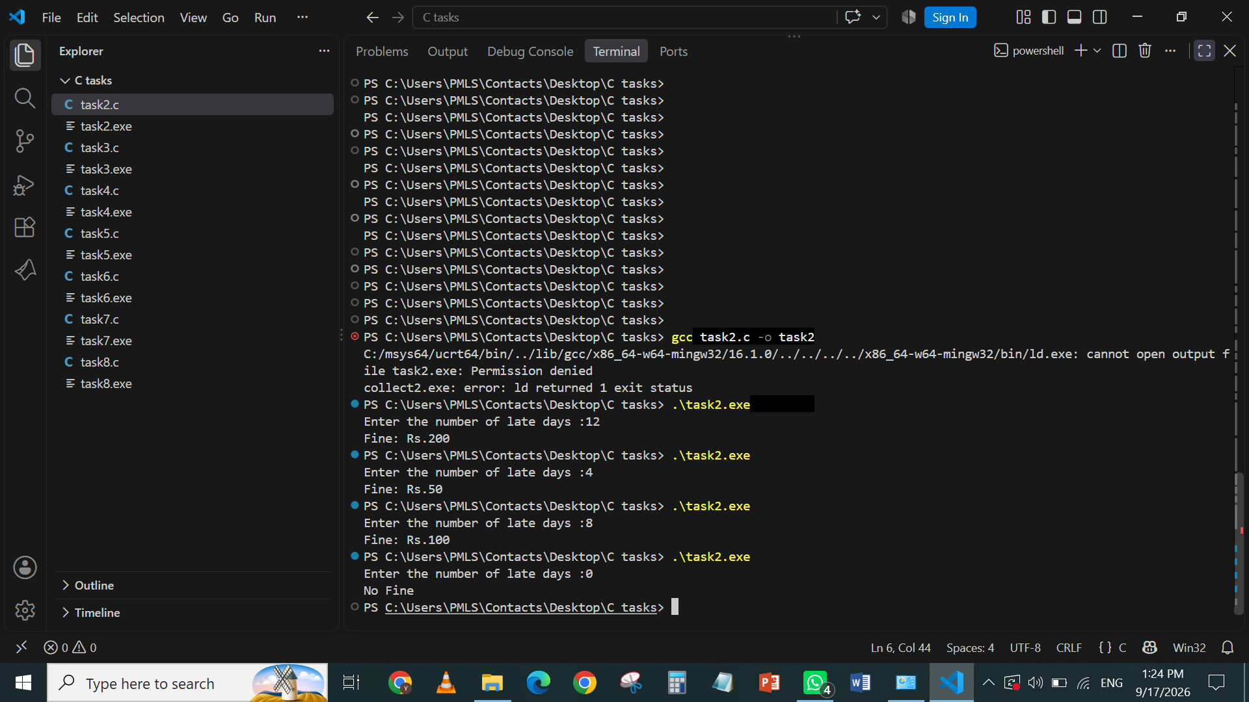
OUTPUT

TASK 3
CODE

#include <stdio.h>

int main()
{
char student_name[80];
puts("Enter student_name :");
fgets(student_name, sizeof(student_name), stdin);
puts("Welcome to Fast University, ");
puts(student_name);

return 0;
}

OUTPUT

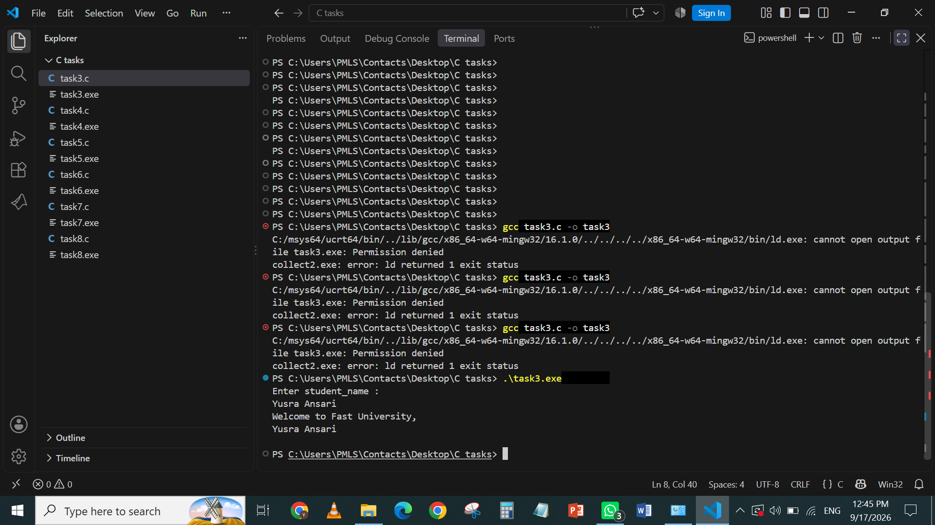

TASK 4
CODE

#include <stdio.h>

int main()
{
float length;
float width;
float area;
float perimeter;
printf("Enter length of a rectangle :");
scanf("%f",&length);
printf("Enter width of a rectangle :");
scanf("%f",&width);
area=length*width;
perimeter=2*(length+width);
printf("Area of the rectangle is %.3f.\n",area);
printf("Perimeter of the rectangle is %.3f.\n",perimeter);

return 0;
}

OUTPUT
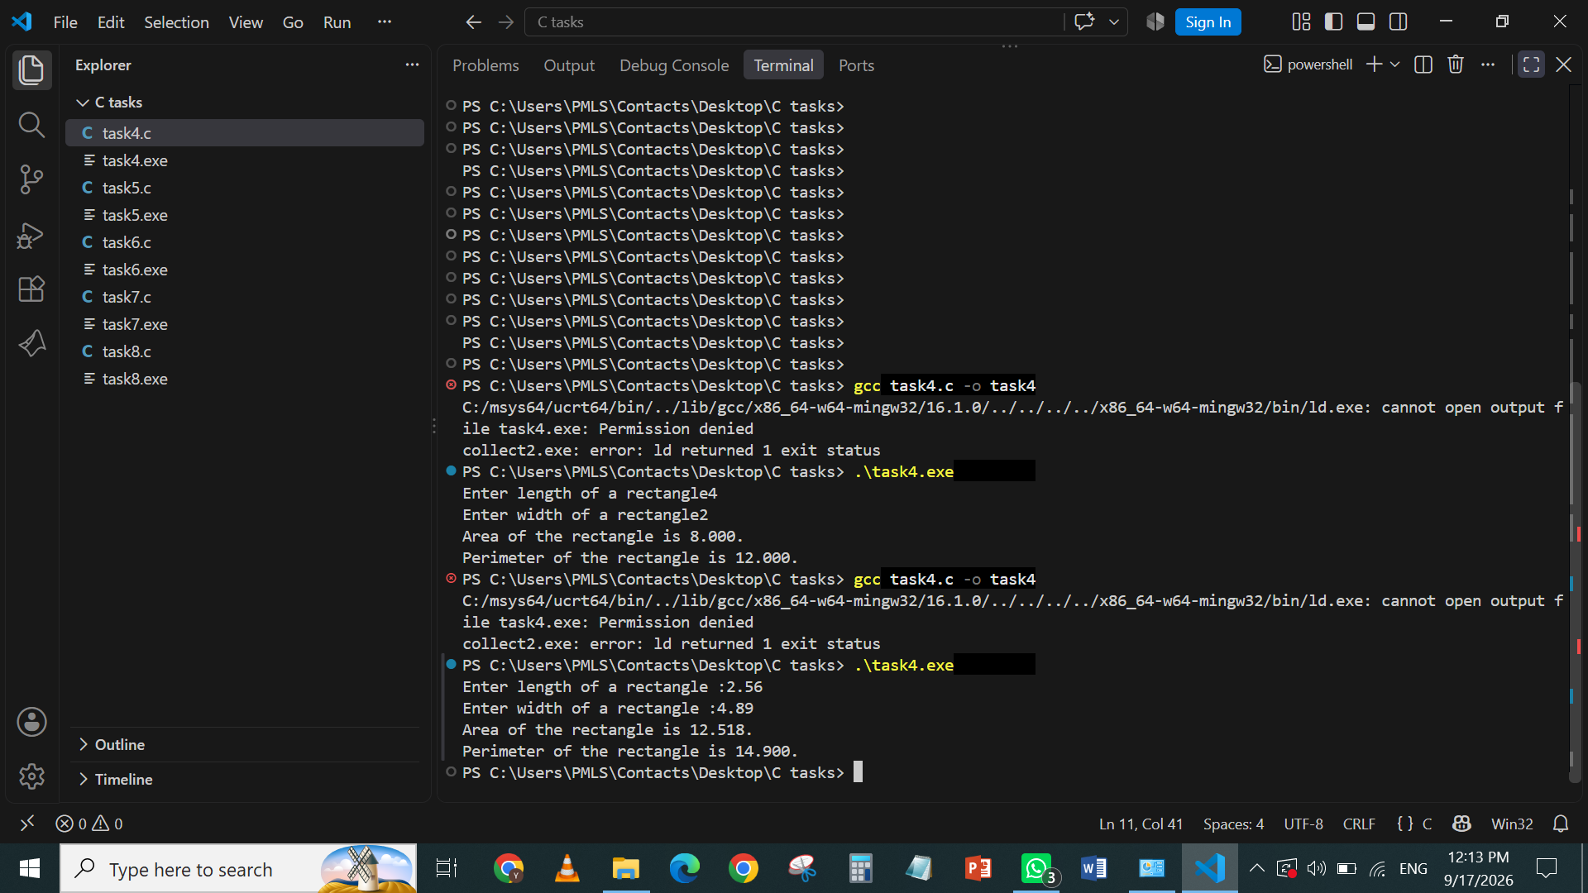

TASK 5
CODE

#include <stdio.h>

int main()
{
int integer;
int square;
int cube;
printf("Enter an integer : ");
scanf("%d", &integer);
square=integer*integer;
cube=integer*integer*integer;
printf("Square of your integer is %d. \n",square);
printf("Cube of your integer is %d. \n",cube);
return 0;

}

OUTPUT

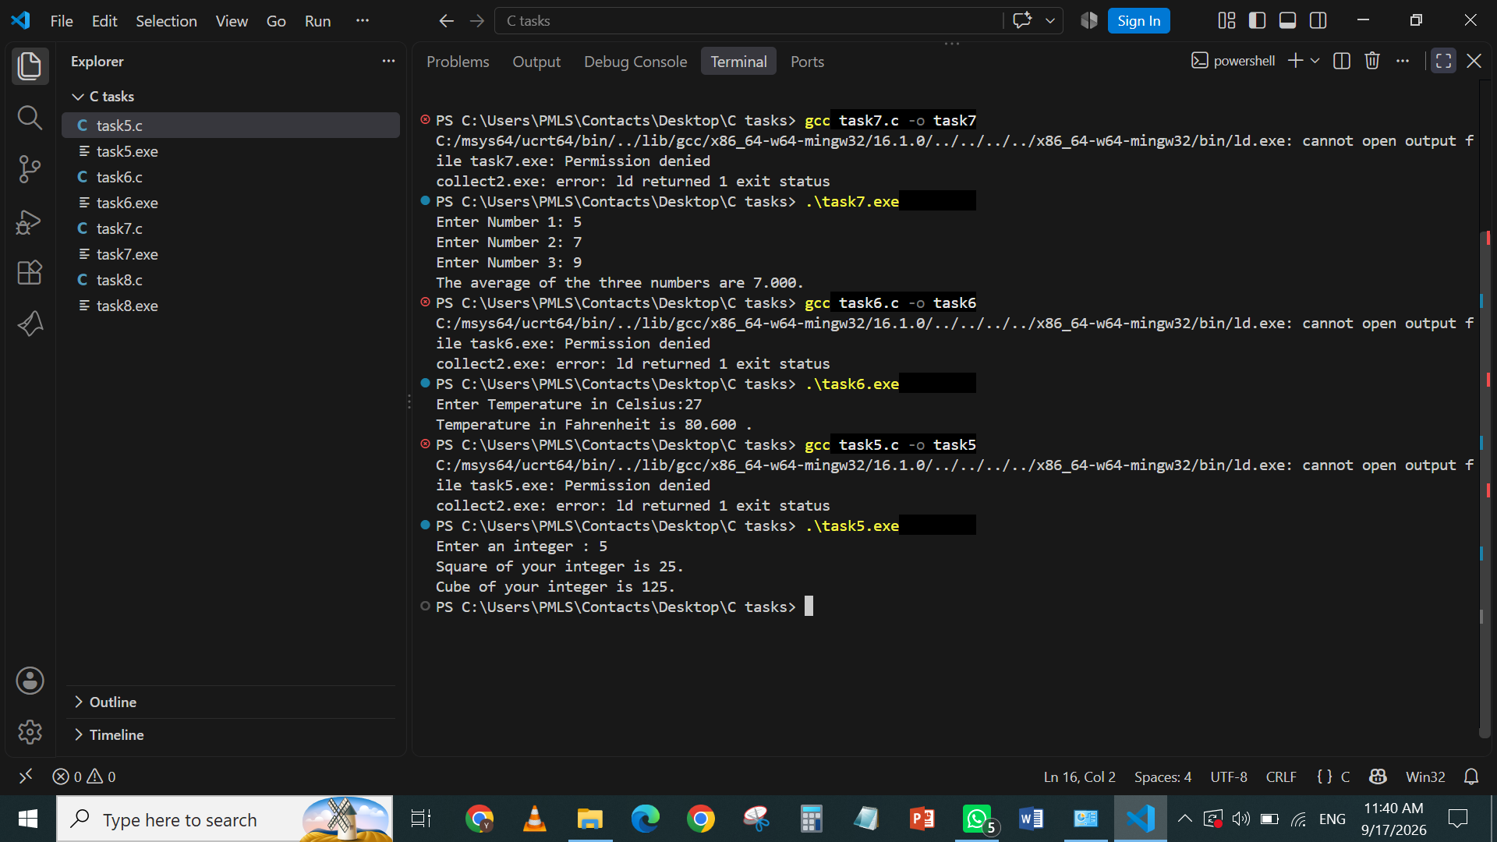

TASK 6
CODE

#include <stdio.h>

int main()
{
float temperature_in_celsius;
float temperature_in_fahrenheit;

printf("Enter Temperature in Celsius:");
scanf("%f", &temperature_in_celsius);
temperature_in_fahrenheit=(temperature_in_celsius*1.8)+32;

printf("Temperature in Fahrenheit is %.3f . \n",temperature_in_fahrenheit);
return 0;
}

OUTPUT
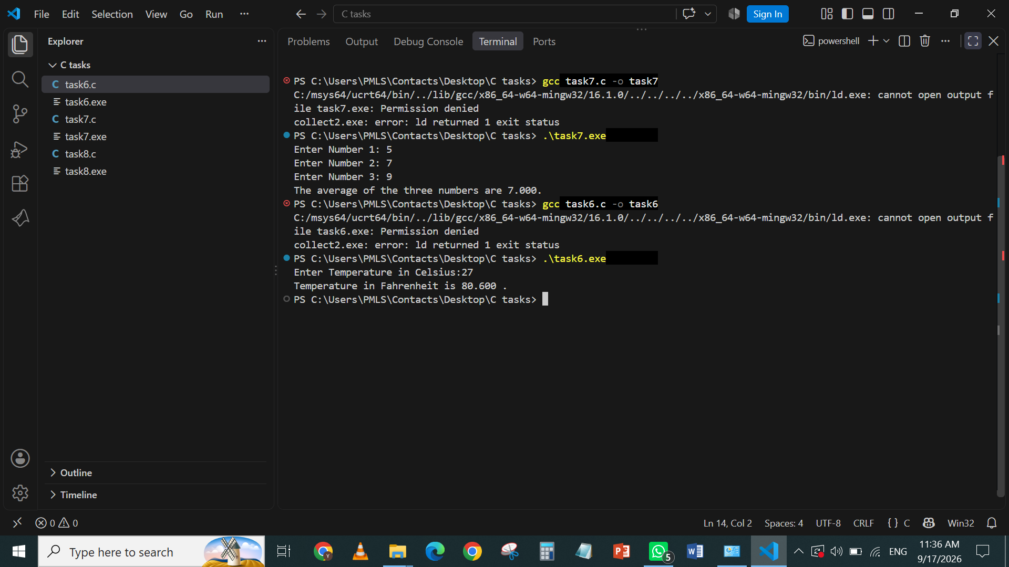

TASK 7
CODE
#include <stdio.h>

int main()
{
float number1;
float number2;
float number3;
float average;

printf("Enter Number 1: ");
scanf("%f", &number1);

printf("Enter Number 2: ");
scanf("%f", &number2);

printf("Enter Number 3: ");
scanf("%f", &number3);

average = (number1 + number2 + number3) / 3;

printf("The average of the three numbers are %.3f.\n", average);

return 0;
}

OUTPUT
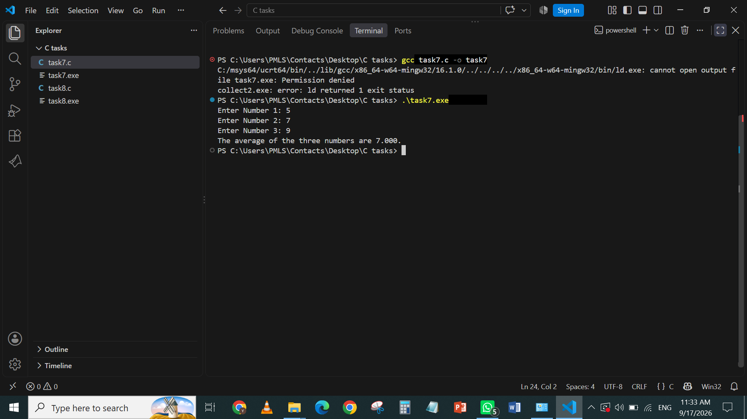

TASK 8

CODE
#include <stdio.h>

int main()
{
float marks;
printf("Enter your marks:");
scanf("%f",&marks);
if(marks>=50){
printf("Pass\n");
}
else{
printf("fail\n");
}
return 0;
}

OUTPUT
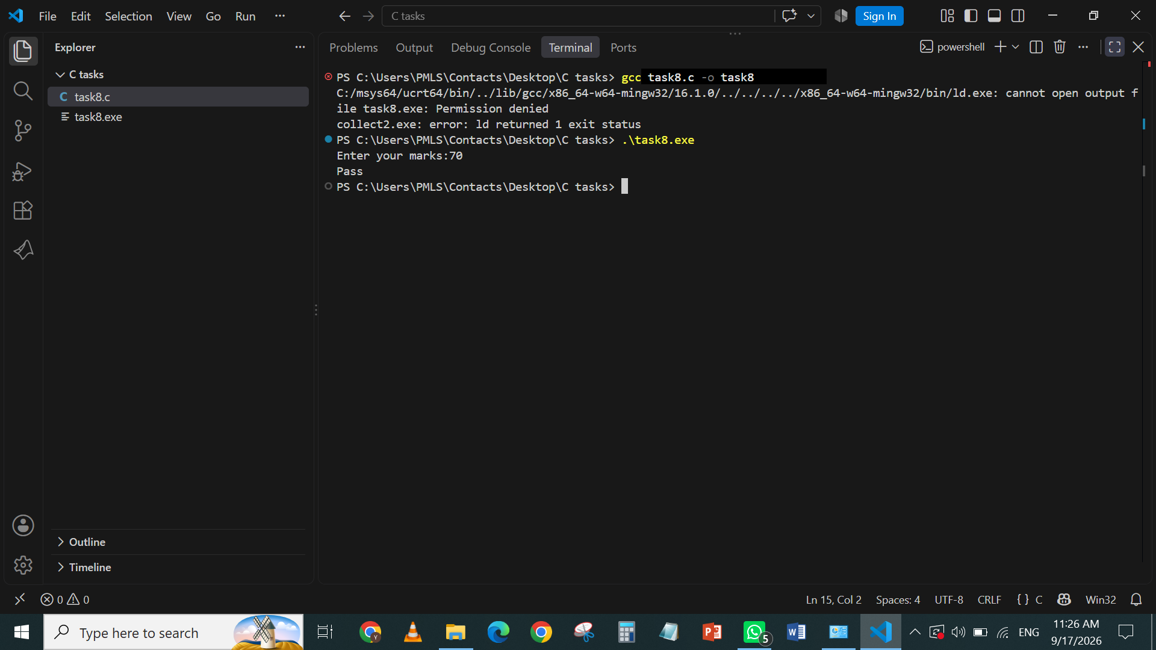

END OF DOCUMENT

